**UniComTicStudents Management**

**ASP.NET MVC Using C#**

## Submitted by:

## Balasubramaniyam Sajikaran

## Roll Number: UT010803

## Institution: UniComTic

## Date of Submission: 21st June 2025

Introduction  
  
This Student Management System is Windows Form ASP.NET MVC and C#. The system is designed to manage student records(courses, subjects, classrooms (halls), exams, and marks).

Admin can add, edit, and delete students, courses, and subjects. Each subject can be assigned a hall and time slot. Exams and marks are entered per student and subject. This system provides a simplified, connected Instution management platform.

Summary OF Report   
  
  
1) Overview of the system and its purpose

2) Technologies used  
  
3) Detailed explanation of each module  
  
**4) Database design and ER diagram**

**5) MVC architecture breakdown** (Models, Views, Controllers) **List of files and documents** created in Visual Studio, including models, controllers, and Razor views

**6) Screenshots** of the working application

**7) Challenges faced** during development

**8) Conclusion and future enhancements**

# Technology used

1)C#  
 2) ASP.Net MVC   
3) System Data SQLiteConnection

MVC Structures  
1) Models  
 (Student.cs,Subject.cs,Course.cs,Exam.cs,Marks.cs,TimeTable.cs,Room.cs)  
  
  
2)Views  
 (StudentForm.cs,SubjectForm.cs,CourseFormcs,ExamForm.cs,MarksForm.cs,TimeTableForm.cs,RoomForm.cs)

3)Controllers  
 (Studentcontrolller.cs,Subjectcontrollercs,Coursecontroller.cs,Examcontroller.cs  
 MarksController.cs,Roomcontroller.cs)

4)DataBase  
 (DataConnection.cs,Datamigration.cs)

5)DataBase Connection  
 (unicomtic.db  
  
  
  
What Challages  
I faced difficulties because I had to repeatedly reconnect the database whenever I created or updated new tables.(my SQLiteNonQuery Doesn’t work it)  
  
  
  
  
ScreenShort OF projects  
  
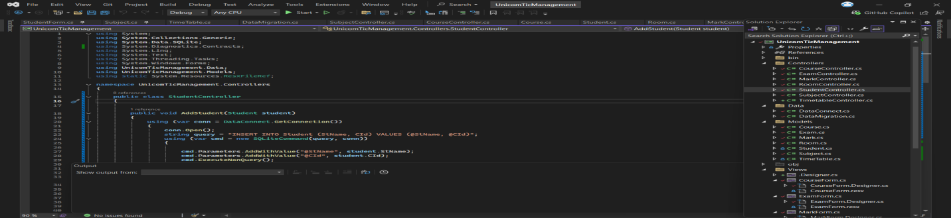  
  
  
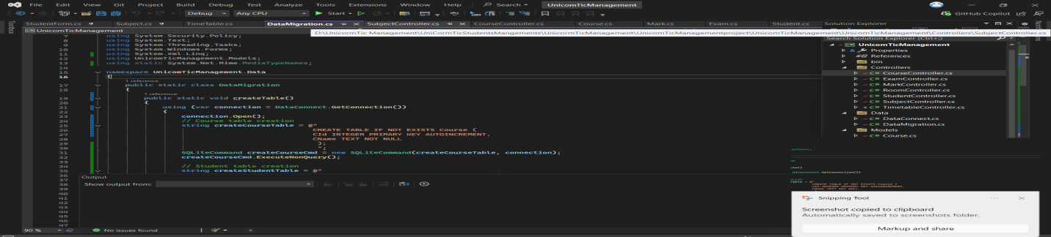

ER Diagram  
  
The ER diagram represents the database structure for the Student Management System. Each student is enrolled in one course. Courses have multiple subjects. Subjects are scheduled in halls with specific times. Students appear in exams per subject, and their marks are stored in the ExamMarks table.  
 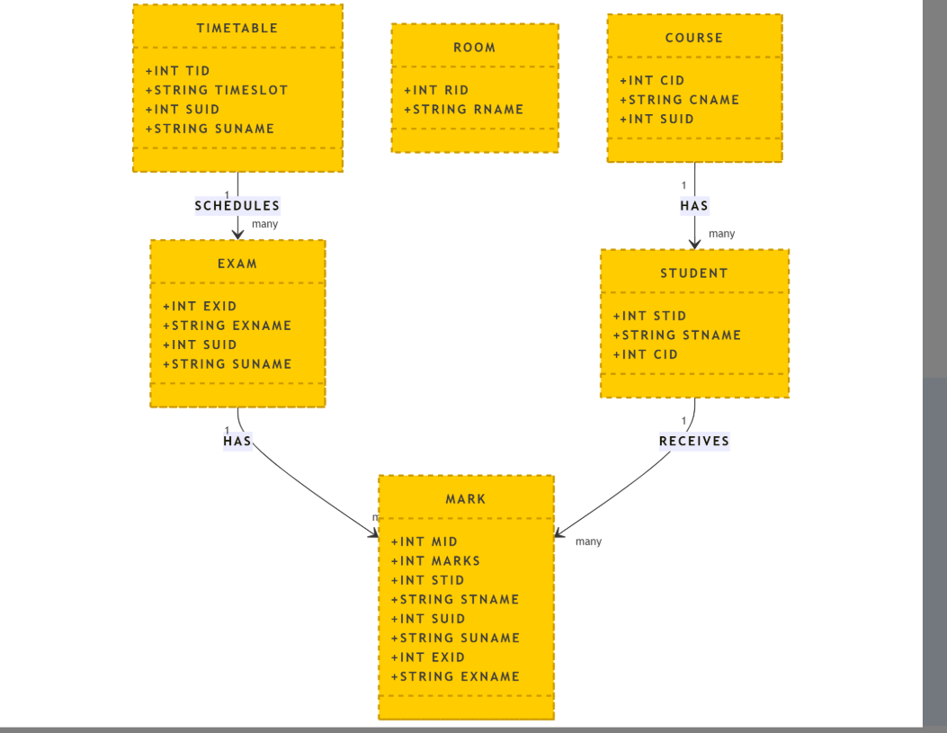

Conclusion  
  
This project helped me understand ASP.NET MVC, and also how to connet the DataBase, and entity relationships.

I successfully built a and how to build Backend in system.  
  
Future Scope  
login System for Users  
lectures stduents details With Hall  
Attendence for Students and Admin and staff and lectures  
  
What learn   
how to use mvc and also how to handle the many handled many entities  
and also how to work in bankend and also how to develop the backend in furture.